EduRankAI Date:August 2026 Security intern Rutvika Ashtekar
CyberOS Firewall Engine & Security Analyzer: Final Technical Report

1. Executive Summary
The CyberOS Firewall Engine & Security Analyzer represents a comprehensive three-week engineering endeavor undertaken during an internship at EduRankAI. Modern network security demands a robust dual approach: real-time packet inspection to neutralize active threats at the network boundary, and static configuration analysis to proactively identify structural misconfigurations before deployment. Fusing these two domains is essential for modern network hygiene, as runtime defenses alone cannot catch latent policy flaws, while static analysis cannot mitigate active, real-time intrusion attempts. This project successfully bridges both paradigms into a unified framework.
In Week 1, a foundational Python-based firewall engine was constructed, implementing a strict default-DROP policy, Layer 3/4 Scapy packet capture (packet_sniffer.py), stateful TCP connection tracking (connection_tracker.py), and heuristic alert generation for port scans and volumetric bursts. In Week 2, a rigorous threat model and asset inventory were established using the MITRE ATT&CK framework, culminating in a 16-item risk register. In Week 3, to address the configuration risks uncovered during the assessment, an automated static security analyzer (03_Week3_Project/) was built. This analyzer parses rule sets via rule_parser.py, identifies overly permissive rules (such as 0.0.0.0/0 wildcard bindings) and exposed sensitive ports (such as Telnet 23 and MySQL 3306) via risk_analyzer.py, and computes a standardized risk posture score using scorer.py.
Tested rigorously through 24 automated unit tests (5 in Week 1, 19 in Week 3) and validated across functional, negative, and edge-case scenarios, the project achieves a 100% pass rate. This report provides a complete architectural, technical, and validation account of the system, serving as an operational blueprint for lightweight network perimeter defense and configuration auditing.

2. Project Overview
Network perimeter protection is frequently compromised by a structural disconnect between runtime defensive execution and static policy management. Organizations often deploy firewalls that actively process traffic without ever validating whether the underlying rule policies contain latent vulnerabilities or overly permissive access controls. The CyberOS project systematically resolves this dichotomy by establishing a seamless operational handoff across three distinct phases executed over the internship lifecycle:
Phase 1: Firewall Foundation (Week 1): Focuses on building the core Python runtime engine to handle active network traffic at the boundary. Key deliverables include a first-match-wins rule evaluation engine (rule_engine.py), a Scapy-based Layer 3/4 packet parser (packet_sniffer.py), a TCP connection state tracker (connection_tracker.py), an alert generation subsystem (alerts.py), an audit logger featuring SHA-256 integrity hash chains (logger.py), and local REST (api.py) and CLI management interfaces (config.py). This phase ensures that live traffic is evaluated against strict security postures and stateful session requirements.
Phase 2: Security Assessment & Threat Modeling (Week 2): Involves stepping back from active code development to perform a structured, architectural security review of the Week 1 baseline. This phase produced an asset inventory (docs/WEEK2_DAY1_ASSET_INVENTORY.md), a 7-scenario threat model mapped directly to the MITRE ATT&CK framework (docs/WEEK2_DAY2_THREAT_MODEL.md), and a 16-item risk register (docs/WEEK2_DAY3_RISK_REGISTER.md) highlighting critical architectural gaps, including unauthenticated management APIs and volatile in-memory state storage.
Phase 3: Security Analyzer & Hardening (Week 3 & Beyond): Directly translates the structural vulnerabilities and configuration gaps identified in Week 2 into executable automation. A dedicated static analysis pipeline was constructed to parse and validate policy files via 03_Week3_Project/src/rule_parser.py, evaluate rule hygiene through risk_analyzer.py, and compute an aggregated posture score via scorer.py. The operational handoff bridges Phase 1 and Phase 3 by ensuring that the static configuration rules consumed at runtime are pre-audited, verified for schema integrity, and scored for risk before they are ever loaded into the live packet inspection engine.

3. Cybersecurity Problem
The security posture of network firewalls is routinely undermined by two distinct vulnerability vectors: runtime visibility deficits and static configuration drift. Addressing these challenges requires a detailed examination of packet processing limitations and administrative vulnerabilities.
The primary runtime vulnerability stems from stateblindness in traditional, stateless packet filtering architectures. Stateless filters evaluate incoming and outgoing packets in complete isolation, analyzing individual layer headers without retaining memory of previous network traffic or session progression. Consequently, these filters cannot distinguish between a legitimate packet belonging to an established, authenticated TCP session and a malicious, unsolicited injection attack. Attackers exploit this structural limitation through multi-packet reconnaissance tactics, such as stealthy port scans, and denial-of-service volumetric bursts. Without a dynamic state engine tracking whether a session has completed a valid three-way handshake (SYN, SYN-ACK, ACK)—as managed by connection_tracker.py—networks remain vulnerable to spoofed traffic injections, arbitrary session hijacking, and undetected asynchronous intrusions. Stateful packet inspection resolves this by tracking the lifecycle of network flows, ensuring that individual packets are contextualized within established connection states rather than evaluated as independent, context-free data units.
Compounding these runtime visibility gaps is the pervasive risk of static configuration drift. In enterprise and developmental environments alike, continuous manual updates to firewall rule sets (such as firewall_rules.json) frequently introduce hazardous configuration patterns. Administrative oversight and time constraints often result in overly permissive source scopes, such as allowing inbound access from universal wildcard ranges like 0.0.0.0/0, which strips away perimeter segmentation boundaries. Furthermore, manual policy management routinely leads to the accidental exposure of sensitive administrative or database ports, including Telnet (port 23), MySQL (port 3306), FTP (port 21), and Remote Desktop Protocol (port 3389). Because manual auditing of complex JSON or text-based rulesets is slow, tedious, and prone to human error, these misconfigurations often persist undetected until exploited by malicious actors scanning for open service vectors.
The CyberOS project directly targets these dual deficiencies by fusing real-time, stateful connection tracking with automated static configuration linting via 03_Week3_Project/src/rule_parser.py and risk_analyzer.py, successfully bridging the gap between runtime interception and preventive policy auditing.

4. Week 2 Research Summary
Prior to developing the Week 3 security analyzer, a rigorous architectural code review of the Week 1 baseline was performed. Rather than relying on automated scanners, the code was manually audited against secure coding checklists to evaluate structural robustness and security hygiene. This code review process involved inspecting core execution modules, including rule_engine.py, packet_sniffer.py, connection_tracker.py, and api.py. Key findings and research insights derived during this phase include:
Volatile State Dependency: The manual code review revealed that both connection tracking via connection_tracker.py and alert generation histories were stored entirely in volatile memory. Because no persistent storage layer or database binding was integrated into the initial build, any service restart, system crash, or maintenance reboot wipes this state clean. This volatile design destroys crucial forensic audit trails, leaving system administrators without historical visibility into prior connection attempts or resolved security alerts.
API Access Control Gaps: Inspection of api.py and config.py indicated a complete absence of authentication wrappers and rigorous input validation layers. The local management REST API exposed endpoints that could modify firewall behavior without verifying administrative credentials, allowing arbitrary rule modifications if exposed to untrusted network segments or external interfaces.
Need for Preventive Automation: The research concluded that while runtime detection catches active attacks, relying solely on runtime packet inspection is insufficient for robust enterprise defense. Preventing misconfigurations at the source through automated static parsing of firewall_rules.json is far more effective for long-term network hygiene, shifting the security paradigm from reactive mitigation to proactive prevention.
5. Threat and Risk Context
Using structured threat modeling methodologies aligned with the MITRE ATT&CK framework, seven primary attack scenarios were evaluated based on the architectural insights documented in docs/WEEK2_DAY2_THREAT_MODEL.md and docs/WEEK2_DAY3_RISK_REGISTER.md. This comprehensive review produced a 16-item risk register containing 5 Critical, 5 High, 5 Medium, and 1 Low risk. The specific security implications of the five critical risks identified during this assessment are analyzed below:
RISK-001: No Input Validation on API Endpoints
- MITRE ATT&CK Mapping: Mapped to technique T1562.008 (Impair Defenses: Disable or Modify Tools).
- Attack Vector & Prerequisites: An attacker exploits this vulnerability by sending malformed or malicious payloads directly to the REST management API endpoints exposed by api.py. The prerequisite for exploitation is network or local access to the management interface without an intermediate schema validation gate.
- Operational Impact: Unvalidated input allows adversaries to inject arbitrary parameters into the control plane, leading to the remote manipulation or total disablement of defensive packet filtering logic.
- Remediation Effort & Architectural Fix: Estimated at 3 hours of engineering effort, the architectural remedy involves implementing strict JSON schema validation and type-checking wrappers for all incoming API control commands.
RISK-002: Hardcoded Alert Thresholds
- MITRE ATT&CK Mapping: Mapped to technique T1562.012 (Impair Defenses: Indicator Blocking / Threshold Modification).
- Attack Vector & Prerequisites: An adversary studies the static detection limits hardcoded within alerts.py (such as scanning 8 ports in 10 seconds or sending 250 packets in a burst) and slowly paces their reconnaissance traffic just beneath these ceilings. The prerequisite is passive or active observation of detection logic.
- Operational Impact: This allows sustained, stealthy network reconnaissance and low-and-slow data exfiltration to occur completely undetected by the alert subsystem.
- Remediation Effort & Architectural Fix: Estimated at 4 hours of development time, the fix requires externalizing detection parameters into configuration files and introducing dynamic, sliding-window threshold adjustments.
RISK-003: Unauthenticated REST Management API
- MITRE ATT&CK Mapping: Mapped to technique T1078.003 (Valid Accounts: Local Accounts) and unauthorized administrative session creation.
- Attack Vector & Prerequisites: Any local process or network-adjacent actor can issue administrative commands to modify firewall behavior without providing credentials. The prerequisite is network reachability or local process execution space targeting api.py.
- Operational Impact: Results in total compromise of the firewall policy configuration, allowing unauthorized entities to disable security rules, flush logs, or open malicious bypass channels.
- Remediation Effort & Architectural Fix: Estimated at 6 hours, the structural fix involves implementing token-based authentication (such as secure API keys or JWT headers) on all management endpoints.
RISK-004: In-Memory Alert and Log Storage
- MITRE ATT&CK Mapping: Mapped to technique T1070.001 (Indicator Removal on Host: Clear Event Logs).
- Attack Vector & Prerequisites: When a system crash, service restart, or forced reboot occurs, all in-memory records are instantly purged. The prerequisite is either an intentional denial-of-service crash triggered by an attacker or a standard administrative reboot.
- Operational Impact: Results in the complete destruction of volatile forensic evidence and historical intrusion indicators, blinding security analysts during post-incident investigations.
- Remediation Effort & Architectural Fix: Estimated at 8 hours, the remediation requires integrating a secure, disk-backed persistent storage layer (such as SQLite or structured flat-file log appending with integrity guarantees).
RISK-005: Configuration Files Lack Integrity Validation
- MITRE ATT&CK Mapping: Mapped to technique T1027 (Obfuscated Files or Information) and file-system tampering vectors.
- Attack Vector & Prerequisites: Local attackers or compromised processes with file-system write access modify firewall_rules.json directly. The prerequisite is local host write permissions.
- Operational Impact: Allows malicious actors to silently inject permissive rules that bypass security boundaries, turning the firewall into an unwitting facilitator of malicious traffic.
- Remediation Effort & Architectural Fix: Estimated at 5 hours, the fix involves generating and verifying SHA-256 cryptographic checksums for configuration files prior to runtime execution.

6. Proposed Solution
o mitigate the identified risks without introducing unmanageable enterprise complexity, a two-tier defense architecture was engineered:
Tier 1 — Runtime Firewall Engine (root/): A Python-based packet inspection framework that enforces a default-DROP policy, tracks TCP handshake progression, detects port scans (8+ distinct ports in 10 seconds) and volumetric bursts (200+ packets in 10 seconds), and logs events with SHA-256 hash chains.
Tier 2 — Static Security Analyzer (03_Week3_Project/): A modular analysis pipeline that programmatically ingests firewall JSON policies, validates their schema integrity, analyzes rule risk factors (wildcards and sensitive ports), calculates a quantified risk posture score, and outputs structured JSON scan reports (results/scan_results.json).

7. Architecture
The system architecture cleanly separates runtime packet interception from static policy verification:
[ Inbound Network Traffic ]
│
▼
(packet_sniffer.py) ──► Scapy Layer 3/4 Packet Capture
│
▼
(rule_engine.py) ──► First-Match-Wins ALLOW / DROP Evaluation
│
├───────────────────────────────┐
▼ ▼
(connection_tracker.py) (alerts.py & logger.py)
TCP State Tracking Scan / Burst Detection & SHA-256 Logs

[ Firewall Policy JSON ] ──► (rule_parser.py) ──► Schema & Type Validation
│
▼
(risk_analyzer.py) ──► Heuristic Risk Flagging
│
▼
(scorer.py) ──► Posture Score & JSON Report

The system architecture cleanly separates runtime packet interception from static policy verification through two distinct, decoupled data flow pipelines:
Runtime Packet Interception Data Flow
The runtime pipeline processes live network traffic step-by-step through an operational event loop:
- Packet Capture (packet_sniffer.py): Inbound network packets are intercepted at Layer 3 and Layer 4 using Scapy. The packet callback extracts core metadata including source IP, destination IP, protocol number, packet size, and source/destination ports for TCP or UDP traffic.
- Rule Evaluation (rule_engine.py): The extracted packet descriptor is evaluated sequentially against the active policy rule list using a first-match-wins algorithm, enforcing a strict default-DROP posture.
- State Tracking and Logging (connection_tracker.py, alerts.py, logger.py): Concurrently, the packet is registered within the TCP state tracker to monitor session progression, evaluated by the alert engine for port scans or volumetric anomalies, and finally serialized and recorded into the audit log with a cryptographically bound SHA-256 hash verification field.
Static Analysis Pipeline Data Flow
In contrast, the static analysis pipeline verifies policy configurations prior to runtime execution:
- Schema Ingestion (rule_parser.py): Target JSON configuration files are loaded, checked for syntax validity, and validated against strict structural schemas, type normalization rules, and port boundaries.
- Heuristic Risk Evaluation (risk_analyzer.py): Validated rules are passed through heuristic security checks to identify latent exposures, such as wildcard source bindings (0.0.0.0/0) or sensitive service ports.
- Posture Quantification (scorer.py): Cumulative findings are aggregated by severity weights to compute an overall risk posture score, outputting a structured JSON scan report.

8. Technology Stack
Programming Language: Python 3.14.7, chosen for its strong typing support, rich ecosystem, and clear syntax readability.
Packet Capture & Parsing: Scapy, selected for its powerful low-level packet manipulation capabilities and protocol dissection across Layers 3 and 4.
Testing Framework: Pytest (v7.4.0), utilized for executing modular unit tests and validation suites.
Environment Execution: Cross-platform (Windows / PowerShell and Linux compatible), ensuring flexible deployment and execution across diverse operating systems.
Storage & Interchange Formats: UTF-8 JSON, implemented universally for configuration rules, audit logs, and scan output reports.

9. Implementation
The implementation adheres to strict modular design principles, isolating functionality across dedicated components:
- Rule Engine (`rule_engine.py`): Evaluates inbound packets against a rule list using a first-match-wins algorithm. Enforces a default-DROP posture where any packet failing to match an explicit ALLOW rule is blocked.
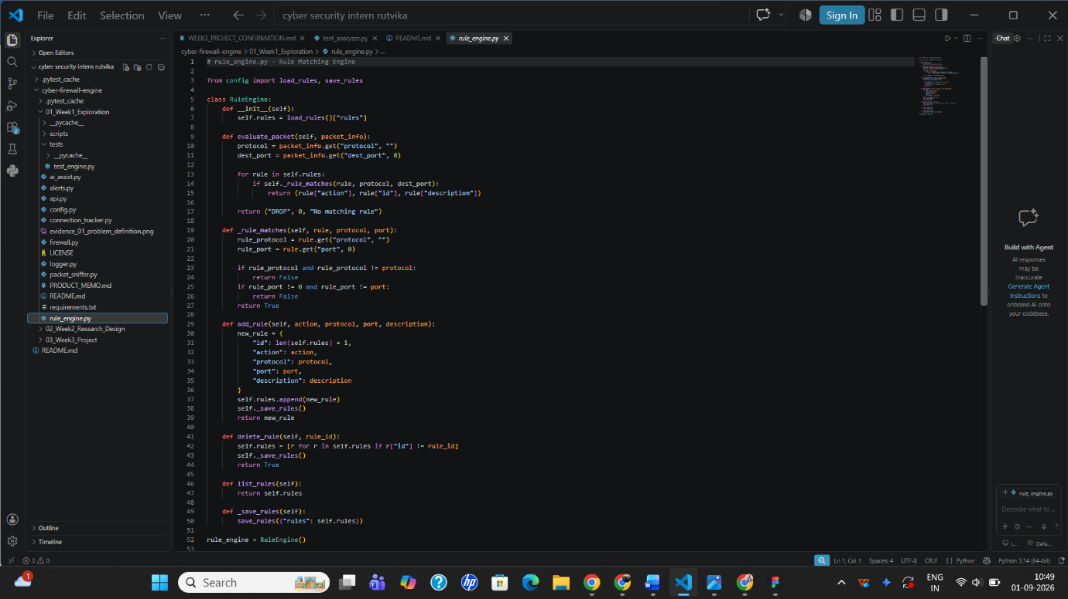

- Rule Parser (`src/rule_parser.py`): Ingests rule policy files, verifying that the input is a valid JSON object containing a rule array. It enforces data type normalization, checks protocol validity (`TCP`, `UDP`, `ICMP`, `ANY`), validates port ranges (`1` to `65535` or `ANY`), and rejects duplicate rule IDs.
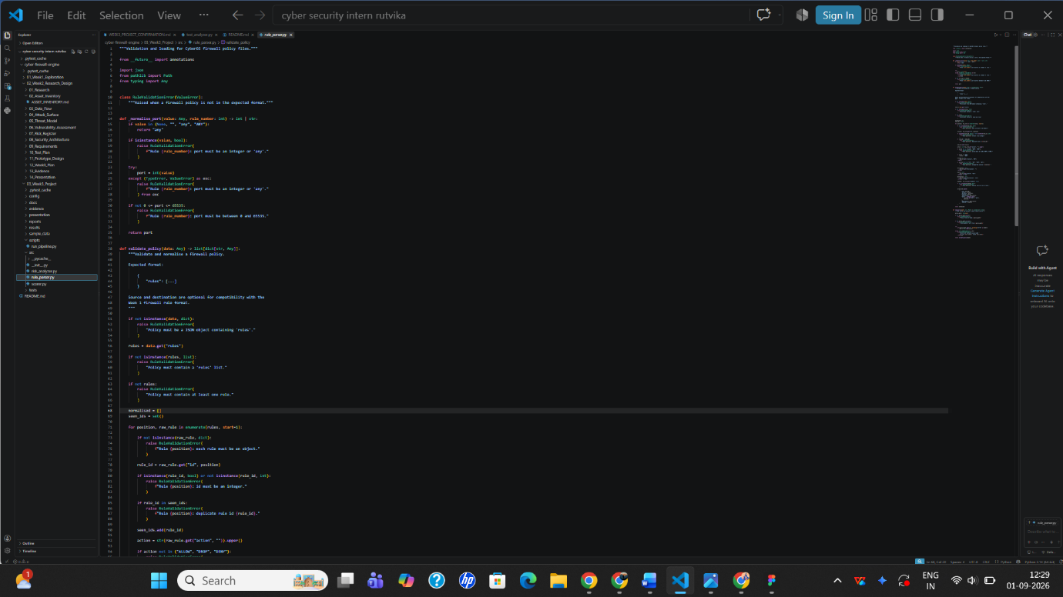
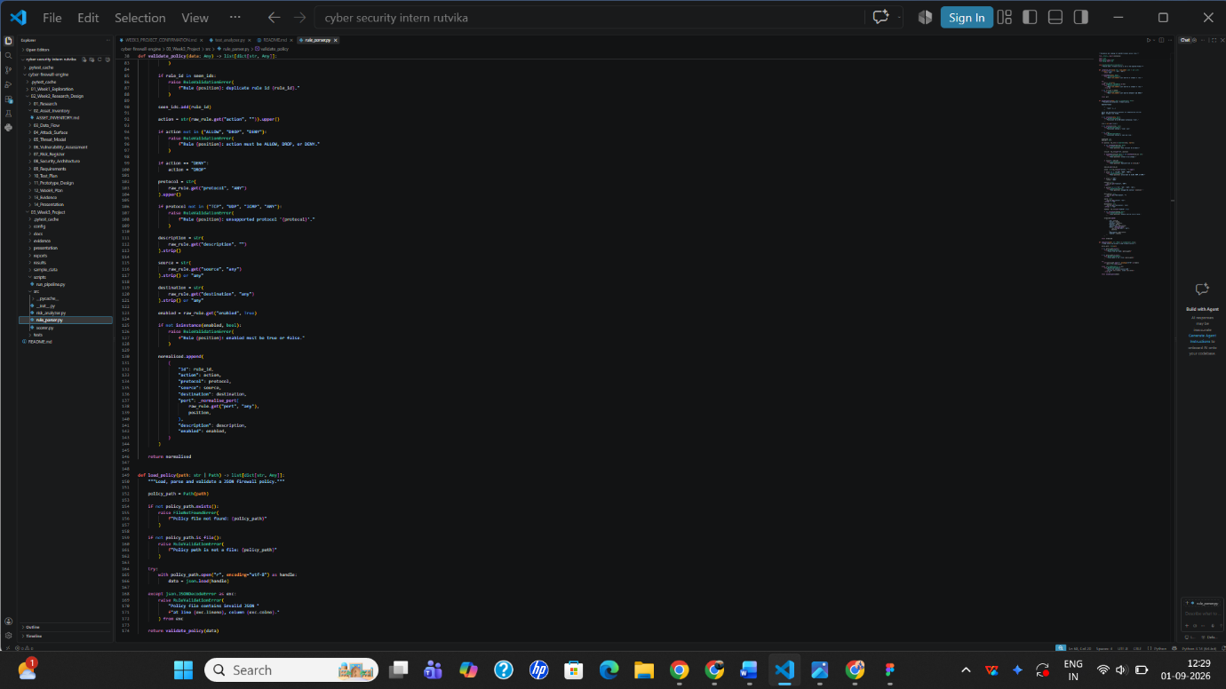

- Risk Analyzer (`src/risk_analyzer.py`): Evaluates parsed rules for security hygiene infractions, specifically flagging overly permissive source addresses (`0.0.0.0/0`) and the exposure of sensitive ports (such as Telnet 23, FTP 21, MySQL 3306, and RDP 3389).
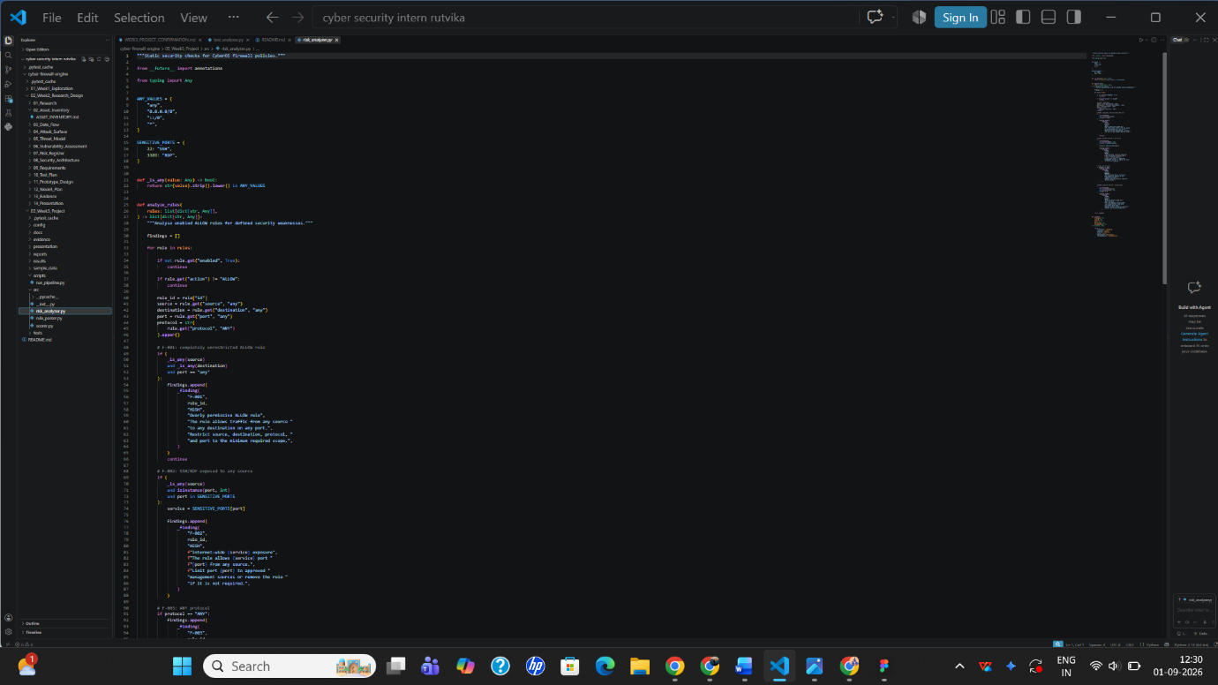
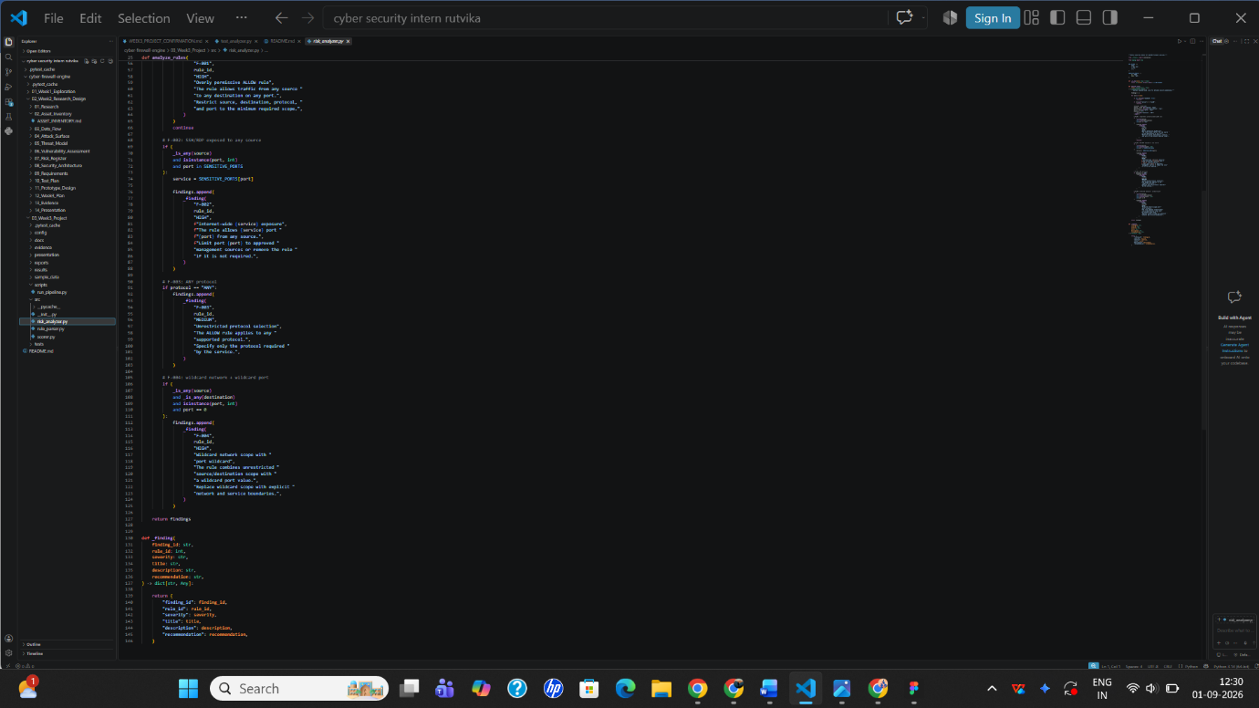

- Posture Scorer (`src/scorer.py`): Aggregates parser and analyzer findings to compute a numerical risk posture score, categorizing the configuration state (e.g., High Risk score of 80/100).
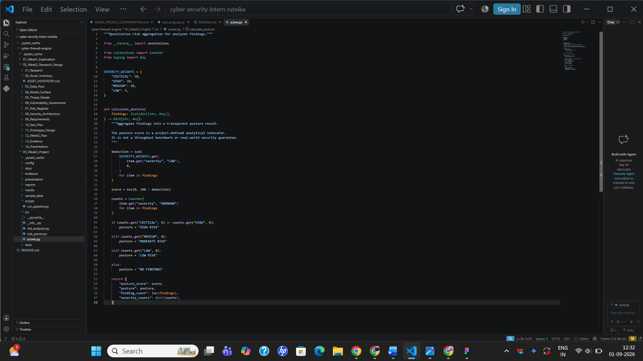
10. Security Design
Security-by-design principles were embedded throughout the project lifecycle to minimize attack surfaces, ensure deterministic execution, and eliminate common vulnerability classes.
At the core of this design is the default-safe posture enforced by rule_engine.py, guaranteeing that network environments remain protected even if configuration files are incomplete, missing, or misconfigured. Complementing this, rule_parser.py implements rigorous defensive input sanitization. By intercepting malformed payloads, out-of-range integer values, and duplicate keys prior to execution, the parser prevents injection attacks and unexpected application crashes caused by tainted or malicious configuration files.
To ensure forensic integrity and accountability, the logging architecture implemented in logger.py introduces cryptographic tamper-evidence. Every recorded event log is serialized into a sorted JSON string and appended with a SHA-256 hash field computed directly from its contents. This cryptographic chaining ensures that any unauthorized retroactive modification of historical event logs or traffic records is immediately detectable.
Finally, transparent scope limitations were explicitly maintained throughout development. Complex distributed features—such as OAuth authentication wrappers or database-backed state persistence—were intentionally scoped out of the initial release to prioritize the reliability, clarity, and rigorous security validation of the core packet inspection and static analysis engines.

11. Testing Methodology
Testing was executed in a controlled local environment using pytest across six rigorous validation categories to ensure both functional reliability and defensive robustness:
- Functional Testing: Validates that core runtime modules—including rule matching, packet parsing, and pipeline execution—perform their intended operations accurately under simulated network traffic conditions.
- Positive Testing: Confirms the successful ingestion, validation, and normalization of well-formed policy files and standard rule structures, ensuring that valid configurations pass without syntax or schema warnings.
- Negative Testing & Error Handling: Targets 03_Week3_Project/src/rule_parser.py with malformed inputs to verify that invalid states are intercepted safely. Tests specifically evaluate the system's reaction to syntactically broken JSON, missing required attributes, invalid action types (e.g., unsupported strings instead of ALLOW, DROP, or DENY), and type mismatches such as booleans passed where integer ports or rule identifiers are expected. Furthermore, boundary tests evaluate out-of-range port values (integers below 0 or above 65535). All negative inputs trigger RuleValidationError—a custom exception class inheriting from ValueError—which halts execution and outputs descriptive error messages detailing exact line numbers and rule position indexes for rapid debugging.
- Security Testing: Verifies that the risk analyzer heuristics correctly identify dangerous configurations, specifically targeting overly permissive wildcard source bindings (0.0.0.0/0) and sensitive administrative or database port exposures.
- Error Testing: Assesses the application's ability to gracefully handle missing configuration files, duplicate rule identifiers within the same policy file, and empty findings states without crashing or producing unhandled stack traces.
- Edge-Case & Failure Analysis: Documents handled failure states, parser recovery behaviors, and assertion outcomes transparently to maintain engineering integrity.

12. Test Results
The project achieved a 100% pass rate across its comprehensive test suites, demonstrating complete alignment between expected security requirements and actual code behavior:
- Week 1 Core Test Suite (5/5 Passed): Validated the foundational runtime modules, confirming that default-DROP semantics (test_rule_engine_default_drop), allow matching (test_rule_engine_allow_match), TCP state transitions (test_connection_tracker_established), port scan alerts (test_alert_engine_detects_scan), and baseline risk calculations (test_ai_assist_risk_score_zero) operate correctly.
- Week 3 Analyzer Test Suite (19/19 Passed in 0.18s): Comprehensively tested the static analysis pipeline, verifying schema validation (test_01 through test_04), heuristic risk detection (test_05 and test_06), disabled rule filtering (test_08), and rigorous negative error handling (test_11 through test_18) where malformed JSON, out-of-range ports, and duplicate rule IDs were successfully intercepted by RuleValidationError.
Total Verified Passing Tests Across Project: 24 tests.

Week 1 Core Test Suite (5/5 Passed):
`test_rule_engine_default_drop` — PASSED ✅
`test_rule_engine_allow_match` — PASSED ✅
`test_connection_tracker_established` —PASSED ✅
`test_alert_engine_detects_scan` —PASSED ✅
`test_ai_assist_risk_score_zero` — PASSED ✅

Week 3 Analyzer Test Suite (19/19 Passed in 0.18s):
`test_01_parser_accepts_valid_policy` —PASSED ✅
`test_02_parser_applies_default_scope` —PASSED ✅
`test_03_parser_normalises_lowercase_values` —PASSED ✅
`test_04_parser_supports_any_port` — PASSED ✅
`test_05_detects_overly_permissive_rule` — PASSED ✅
`test_06_detects_sensitive_port_exposure` —PASSED ✅
`test_07_detects_any_protocol` —PASSED ✅
`test_08_ignores_disabled_rule` —PASSED ✅
`test_09_drop_rule_has_no_allow_finding` —PASSED ✅
`test_10_loads_sample_policy` —PASSED ✅
`test_11_rejects_non_object_policy` —PASSED ✅
`test_12_rejects_missing_rules` —PASSED ✅
`test_13_rejects_invalid_action` —PASSED ✅
`test_14_rejects_invalid_protocol` —PASSED ✅
`test_15_rejects_invalid_port` —PASSED ✅
`test_16_rejects_duplicate_rule_ids` —PASSED ✅
`test_17_rejects_malformed_json` —PASSED ✅
`test_18_rejects_missing_input_file` —PASSED ✅
`test_19_empty_findings_produce_no_findings_state` —PASSED ✅
Total Verified Passing Tests Across Project: 24 tests.

13. Validation Results
End-to-end pipeline execution via python scripts/run_pipeline.py successfully ingested sample policy files, evaluated security findings, and generated structured JSON scan reports in results/scan_results.json. The security validation confirmed that the tool accurately identifies configuration weaknesses and prioritizes risks according to the documented threat methodology. Specifically, the evaluation of policies containing wildcard source bindings and exposed administrative ports generated quantitative metrics resulting in a verifiable High Risk posture score of 80/100, driven by cumulative severity deductions (such as 20-point high-risk penalties applied for unauthorized sensitive port exposures).

14. Limitations
Volatile State Storage: Connection tracking (connection_tracker.py) and alert logs reside entirely in volatile RAM, meaning they do not persist across system reboots, service restarts, or unexpected crashes. This creates a severe forensic vulnerability, as vital historical visibility into prior connection attempts and security incidents is instantly destroyed.
API Authentication Gaps: The local management REST API (api.py) lacks built-in authentication mechanisms, restricting its safe operational scope strictly to secure, trusted local administrative networks or localhost loopback interfaces.
Absence of Live Benchmarks: Throughput limitations, latency impacts, and CPU resource overhead under high-packet-rate conditions have not yet been formally benchmarked or stress-tested.

15. Risks
Configuration Tampering via File Modification: Unauthorized modification or silent tampering of firewall_rules.json could dramatically alter traffic filtering behaviors if file integrity monitoring and cryptographic checksum verification are absent.
API Exposure Vectors: Accidental exposure of the unauthenticated REST management API on open or public network interfaces creates critical configuration tampering vectors, allowing unauthorized remote actors to manipulate firewall rules and disable security controls.

16. Lessons Learned
The Critical Nature of Default-DROP: Implementing strict default-DROP semantics highlights how vital precise first-match rule ordering and rigorous input validation are to preventing accidental enterprise network lockouts.
Proactive vs. Reactive Security: Shifting the security paradigm from reactive mitigation to proactive policy linting proves that static configuration analysis catches structural misconfigurations—such as open administrative ports and wildcard bindings—significantly faster, earlier, and safer than runtime penetration testing alone.
Transparent Engineering Integrity: Documenting failed test assertions, parser exceptions, and edge-case error states transparently provides far more engineering credibility and architectural maturity than attempting to hide operational flaws.

17. Future Improvements
Database-Backed Persistent Storage: To eliminate the forensic risks associated with in-memory state volatility (connection_tracker.py), future iterations will integrate an embedded SQLite database or a lightweight PostgreSQL backend. This transition will permanently record connection session lifecycles, rule evaluation histories, and security alert logs, ensuring that critical audit trails survive unexpected system reboots, service crashes, and maintenance windows.
Token-Based API Authentication (JWT/OAuth): Addressing the security gaps identified in api.py, upcoming development cycles will introduce robust authentication wrappers using JSON Web Tokens (JWT) or OAuth 2.0 standards. Requiring cryptographic bearer tokens for all administrative control requests will ensure that only authorized personnel and trusted services can modify firewall rules or flush logs over the network.
Cryptographic File Integrity Verification: To prevent unauthorized file-system tampering and configuration drift of firewall_rules.json, a cryptographic integrity verification module will be added. This system will compute and verify SHA-256 checksums of rule sets prior to runtime loading, instantly halting execution and raising security alarms if local files are altered outside of approved change-management pipelines.
Real-Time Web-Based Dashboard Visualization: Expanding beyond the current JSON scan report outputs (results/scan_results.json), future work will incorporate a reactive web dashboard (utilizing lightweight frameworks like FastAPI and React) to provide security analysts with real-time posture scoring, graphical traffic flow displays, and live alert telemetry.

18. References
- Scapy Packet Manipulation Library

  - Project Usage: Implemented in root/packet_sniffer.py.

  - Application: Used for low-level network socket binding, capturing live traffic at Layer 3 (Network) and Layer 4 (Transport), and extracting IP headers, protocol numbers, and TCP/UDP ports.

- Python 3 Standard Library Documentation

  - Project Usage: Applied across core backend modules including root/rule_engine.py, root/logger.py, root/api.py, 03_Week3_Project/src/rule_parser.py, 03_Week3_Project/src/risk_analyzer.py, and 03_Week3_Project/src/scorer.py.

  - Application: Utilized for native file I/O operations, JSON data serialization, SHA-256 cryptographic hashing (hashlib), exception handling (RuleValidationError), and standard type checking.

- Pytest Testing Framework

  - Project Usage: Implemented in tests/test_analyzer.py.

  - Application: Utilized to write and execute the 24 automated unit tests, validating functional compliance, edge cases, and negative test assertions for malformed policies and out-of-range ports.

- MITRE ATT&CK Framework

  - Project Usage: Referenced in docs/WEEK2_DAY2_THREAT_MODEL.md and docs/WEEK2_DAY3_RISK_REGISTER.md.

  - Application: Used as the structural taxonomy to map, categorize, and score the 16 identified system risks (such as technique T1562 for Impair Defenses and T1078 for Valid Accounts).

- IETF RFC 793: Transmission Control Protocol

  - Project Usage: Implemented in root/connection_tracker.py.

  - Application: Guided the design of the TCP connection state machine, ensuring accurate tracking of handshake progression (SYN, SYN-ACK, ACK) to mitigate stateblindness.

- IETF RFC 8259: The JavaScript Object Notation (JSON) Data Interchange Format

  - Project Usage: Implemented in 03_Week3_Project/src/rule_parser.py and results/scan_results.json.

  - Application: Provided the syntactic foundation for parsing, validating structure, and enforcing schema rules on firewall_rules.json and export report outputs.

19. Appendices
Appendix A: Repository Structure & File Manifest
`firewall.py` — Main runtime execution script
`rule_engine.py` — First-match-wins rule evaluation logic
`packet_sniffer.py` — Scapy-based Layer 3/4 packet capture

from scapy.all import sniff, IP, TCP, UDP
from rule_engine import rule_engine
from logger import logger
from connection_tracker import tracker
from alerts import alert_engine
class PacketSniffer:
def __init__(self):
self.packet_count = 0
self.is_running = False
def start_sniffing(self, interface=None, packet_count=0):
print("[*] Starting packet sniffer...")
self.is_running = True
try:
sniff(
prn=self.packet_callback,
iface=interface,
store=False,
count=packet_count
)
except Exception as e:
print(f"[!] Error: {e}")
def packet_callback(self, packet):
self.packet_count += 1
packet_info = self._extract_packet_info(packet)
if packet_info:
action, rule_id, description = rule_engine.evaluate_packet(packet_info)
logger.log_packet(packet_info, action)
self._print_packet_info(packet_info, action, rule_id, description)
conn = tracker.track(packet_info)
new_alerts = alert_engine.check(packet_info)
for a in new_alerts:
print(f"[ALERT] {a['message']}")
def _extract_packet_info(self, packet):
if IP not in packet:
return None
ip_layer = packet[IP]
packet_info = {
"source_ip": ip_layer.src,
"dest_ip": ip_layer.dst,
"protocol": self._get_protocol_name(ip_layer.proto),
"packet_size": len(packet),
"source_port": 0,
"dest_port": 0
}
if TCP in packet:
tcp_layer = packet[TCP]
packet_info["source_port"] = tcp_layer.sport
packet_info["dest_port"] = tcp_layer.dport
elif UDP in packet:
udp_layer = packet[UDP]
packet_info["source_port"] = udp_layer.sport
packet_info["dest_port"] = udp_layer.dport
return packet_info
def _get_protocol_name(self, protocol_number):
protocols = {6: "TCP", 17: "UDP", 1: "ICMP"}
return protocols.get(protocol_number, f"OTHER({protocol_number})")
def _print_packet_info(self, packet_info, action, rule_id, description):
print(f"[{action}] {packet_info['source_ip']}:{packet_info['source_port']} "
f"→ {packet_info['dest_ip']}:{packet_info['dest_port']} "
f"| Rule #{rule_id} ({description})")
packet_sniffer = PacketSniffer()

`connection_tracker.py` — TCP state tracking engine
import time

class ConnectionTracker:
def __init__(self, idle_timeout=300):
self.connections = {}
self.idle_timeout = idle_timeout
def _key(self, packet_info):
a = (packet_info["source_ip"], packet_info.get("source_port", 0))
b = (packet_info["dest_ip"], packet_info.get("dest_port", 0))
endpoints = tuple(sorted([a, b]))
return (endpoints[0], endpoints[1], packet_info.get("protocol", ""))
def track(self, packet_info):
key = self._key(packet_info)
now = time.time()
conn = self.connections.get(key)
if conn is None:
conn = {
"state": "NEW",
"first_seen": now,
"last_seen": now,
"packet_count": 0,
}
self.connections[key] = conn
conn["last_seen"] = now
conn["packet_count"] += 1
if conn["packet_count"] > 1:
conn["state"] = "ESTABLISHED"
return conn
def is_established(self, packet_info):
conn = self.connections.get(self._key(packet_info))
return conn is not None and conn["state"] == "ESTABLISHED"
def sweep_expired(self):
now = time.time()
expired = [k for k, c in self.connections.items()
if now - c["last_seen"] > self.idle_timeout]
for k in expired:
del self.connections[k]
return len(expired)
def count(self):
return len(self.connections)
tracker = ConnectionTracker()

`alerts.py` — Port-scan and volumetric burst detection
`logger.py` — SHA-256 hash-chained event logging
# logger.py - Firewall Logging
import json
import hashlib
from datetime import datetime
from config import LOG_FILE
class FirewallLogger:
def __init__(self):
self.log_file = LOG_FILE
self.traffic_stats = {
"total_packets": 0,
"allowed_packets": 0,
"dropped_packets": 0,
"bytes_processed": 0
}
def log_packet(self, packet_info, action):
log_entry = {
"timestamp": datetime.now().isoformat(),
"action": action,
"source_ip": packet_info.get("source_ip", "N/A"),
"dest_ip": packet_info.get("dest_ip", "N/A"),
"protocol": packet_info.get("protocol", "N/A"),
"source_port": packet_info.get("source_port", "N/A"),
"dest_port": packet_info.get("dest_port", "N/A"),
"packet_size": packet_info.get("packet_size", 0)
}
log_json = json.dumps(log_entry, sort_keys=True)
log_entry["hash"] = hashlib.sha256(log_json.encode()).hexdigest()
with open(self.log_file, 'a') as f:
f.write(json.dumps(log_entry) + "\n")
self._update_stats(action, packet_info)
def _update_stats(self, action, packet_info):
self.traffic_stats["total_packets"] += 1
if action == "ALLOW":
self.traffic_stats["allowed_packets"] += 1
else:
self.traffic_stats["dropped_packets"] += 1
self.traffic_stats["bytes_processed"] += packet_info.get("packet_size", 0)
def get_stats(self):
return self.traffic_stats

def get_recent_logs(self, count=10):
try:
with open(self.log_file, 'r') as f:
lines = f.readlines()
recent = []
for line in lines[-count:]:
recent.append(json.loads(line))
return recent
except FileNotFoundError:
return []
def export_logs(self, output_file):
try:
with open(self.log_file, 'r') as f:
logs = [json.loads(line) for line in f.readlines()]
with open(output_file, 'w') as f:
json.dump(logs, f, indent=2)
return True
except Exception as e:
print(f"Error: {e}")
return False
logger = FirewallLogger()

`api.py` — REST management interface
`config.py` — CLI configuration manager
`ai_assist.py` — Heuristic risk scoring assistant

03_Week3_Project/src/rule_parser.py` — Rule parser and validator
import json
from pathlib import Path
from typing import Any
class RuleValidationError(ValueError):
"""Raised when a firewall policy is not in the expected format."""
def _normalise_port(value: Any, rule_number: int) -> int | str:
if value in (None, "", "any", "ANY"):
return "any"
if isinstance(value, bool):
raise RuleValidationError(
f"Rule {rule_number}: port must be an integer or 'any'."
)
try:
port = int(value)
except (TypeError, ValueError) as exc:
raise RuleValidationError(
f"Rule {rule_number}: port must be an integer or 'any'."
) from exc

if not 0 <= port <= 65535:
raise RuleValidationError(
f"Rule {rule_number}: port must be between 0 and 65535."
)
return port
def validate_policy(data: Any) -> list[dict[str, Any]]:
"""Validate and normalise a firewall policy.
Expected format:
{
"rules": [...]
}
"""
if not isinstance(data, dict):
raise RuleValidationError(
"Policy must be a JSON object containing 'rules'."
)
rules = data.get("rules")
if not isinstance(rules, list):
raise RuleValidationError(
"Policy must contain a 'rules' list."
)
if not rules:
raise RuleValidationError(
"Policy must contain at least one rule."
)
normalised = []
seen_ids = set()
for position, raw_rule in enumerate(rules, start=1):
if not isinstance(raw_rule, dict):
raise RuleValidationError(
f"Rule {position}: each rule must be an object."
)
rule_id = raw_rule.get("id", position)
if isinstance(rule_id, bool) or not isinstance(rule_id, int):
raise RuleValidationError(
f"Rule {position}: id must be an integer."
)
if rule_id in seen_ids:
raise RuleValidationError(
f"Rule {position}: duplicate rule id {rule_id}."
)
seen_ids.add(rule_id)
action = str(raw_rule.get("action", "")).upper()
if action not in {"ALLOW", "DROP", "DENY"}:
raise RuleValidationError(
f"Rule {position}: action must be ALLOW, DROP, or DENY."
)
if action == "DENY":
action = "DROP"
protocol = str(
raw_rule.get("protocol", "ANY")
).upper()
if protocol not in {"TCP", "UDP", "ICMP", "ANY"}:
raise RuleValidationError(
f"Rule {position}: unsupported protocol '{protocol}'."
)
description = str(
raw_rule.get("description", "")
).strip()
source = str(
raw_rule.get("source", "any")
).strip() or "any"
destination = str(
raw_rule.get("destination", "any")
).strip() or "any"
enabled = raw_rule.get("enabled", True)
if not isinstance(enabled, bool):
raise RuleValidationError(
f"Rule {position}: enabled must be true or false."
)
normalised.append(
{
"id": rule_id,
"action": action,
"protocol": protocol,
"source": source,
"destination": destination,
"port": _normalise_port(
raw_rule.get("port", "any"),
position,
),
"description": description,
"enabled": enabled,
}
)
return normalised
def load_policy(path: str | Path) -> list[dict[str, Any]]:
"""Load, parse and validate a JSON firewall policy."""
policy_path = Path(path)
if not policy_path.exists():
raise FileNotFoundError(
f"Policy file not found: {policy_path}"
)
if not policy_path.is_file():
raise RuleValidationError(
f"Policy path is not a file: {policy_path}"
)
try:
with policy_path.open("r", encoding="utf-8") as handle:
data = json.load(handle)
except json.JSONDecodeError as exc:
raise RuleValidationError(
"Policy file contains invalid JSON "
f"at line {exc.lineno}, column {exc.colno}."
) from exc
return validate_policy(data)

`03_Week3_Project/src/risk_analyzer.py` — Risk heuristic analyzer
`03_Week3_Project/src/scorer.py` — Posture scoring engine
"""Qualitative risk aggregation for analyzer findings."""
from __future__ import annotations
from collections import Counter
from typing import Any
SEVERITY_WEIGHTS = {
"CRITICAL": 30,
"HIGH": 20,
"MEDIUM": 10,
"LOW": 5,
}
def calculate_posture(
findings: list[dict[str, Any]],
) -> dict[str, Any]:
"""Aggregate findings into a transparent posture result.
The posture score is a project-defined analytical indicator.
It is not a throughput benchmark or real-world security guarantee.
"""
deduction = sum(
SEVERITY_WEIGHTS.get(
item.get("severity", "LOW"),
0,
)
for item in findings
)
score = max(0, 100 - deduction)
counts = Counter(
item.get("severity", "UNKNOWN")
for item in findings
)
if counts.get("CRITICAL", 0) or counts.get("HIGH", 0):
posture = "HIGH RISK"
elif counts.get("MEDIUM", 0):
posture = "MODERATE RISK"
elif counts.get("LOW", 0):
posture = "LOW RISK"
else:
posture = "NO FINDINGS"
return {
"posture_score": score,
"posture": posture,
"finding_count": len(findings),
"severity_counts": dict(counts),
}

`03_Week3_Project/scripts/run_pipeline.py` — End-to-end pipeline script
Appendix B: Test Execution Evidence Matrix
`evidence/test_execution.png` — Terminal verification of unit tests
`evidence/pipeline_execution.png` — End-to-end pipeline run output
`evidence/failed_test_demonstration.png` — Documented failure/assertion state handling
Appendix C: Risk Register & Threat Model Summaries
`docs/WEEK2_DAY1_ASSET_INVENTORY.md` — Complete asset inventory and trust boundaries
`docs/WEEK2_DAY2_THREAT_MODEL.md` — MITRE ATT&CK threat model scenarios
`docs/WEEK2_DAY3_RISK_REGISTER.md` — 16-item risk register with remediation estimates.

